INTERNSHIP PROJECT REPORT

CUSTOMER PURCHASE BEHAVIOUR ANALYSIS USING PYTHON, POSTGRESQL AND POWER BI

Submitted in Partial Fulfilment of the Requirements for the
DATA ANALYSIS INTERNSHIP

Submitted By
RAYAAN ANN GEORGE
Rajagiri School of Engineering and Technology

Under the Guidance of
Ms. ASHVITHA DOMINIC

Internship Organization
TAMIL NADU SMART AND ADVANCED MANUFACTURING CENTER - TANSAM

Academic Year
2026 – 2027

Project Abstract
This project focuses on understanding how customers shop and using that information to help businesses make smarter choices. Every time a customer buys something, they leave behind valuable clues about what they like, how much they spend, and when they prefer to shop. To turn these raw numbers into useful business strategies, this project builds a complete, step-by-step data system. We clean the messy customer information, store it safely in a structured database, analyse the hidden trends, and finally build an easy-to-use, interactive visual dashboard. This dashboard gives business owners a clear, real-time look at their sales performance and customer habits so they can make quick, confident decisions.

Step-by-Step Project Breakdown
- Data Cleaning and Preparation (Google Colab & Jupyter Notebook) : Raw business data is usually messy, full of mistakes, missing information, and duplicate entries that can ruin final calculations. Using Python inside Google Colab and Jupyter Notebook, the data was thoroughly cleaned. Incomplete records were fixed, duplicate purchases were deleted, and shopping categories were standardized so that everything was perfectly accurate before the actual analysis began.
- Structured Storage and Querying (PostgreSQL) : Once the data was clean and organized, it was moved into a powerful relational database called PostgreSQL. Storing the information here makes it safe and highly organized. Using SQL (Structured Query Language), specific commands were written to sort through thousands of customer data instantly, group them together, and calculate important metrics like total revenue, average spending, and top-selling products.
- Visual Dashboard Creation (Power BI) : To make the data easy for anyone to understand without reading rows of numbers, PostgreSQL was connected directly to Power BI. This tool was used to design an interactive, click-and-explore dashboard. Instead of static text, the dashboard uses colourful charts and graphs to display customer ages, genders, subscription choices, product ratings, and overall shopping habits.
- Driving Business Growth and Smart Marketing : The final dashboard acts as a visual guide for the company's management team. By looking at the charts, businesses can instantly spot which items are highly rated, whether subscribers spend more than non-subscribers, and which age groups buy the most products. These insights allow companies to create better marketing campaigns, stop wasting money on low-performing items, and improve customer satisfaction.

Executive Summary
Understanding how customers shop is the best way for a business to grow, make smart choices, and save time. This project takes raw sales numbers and transforms them into clear, useful business insights. We built a complete data system that cleans the messy information using Google Colab and Jupyter Notebook, stores it safely in a PostgreSQL database, and displays it visually using a Power BI dashboard. This dashboard helps company leaders instantly see who is buying their products, what is selling the most, and where the business can make more money.

Key Takeaways from the Data
- Total Sales: The business made around 233,000 units of revenue from nearly 3,900 customers.
- Top Product: Clothing is the most successful category, bringing in about 43% of all the company's revenue.
- Gender Spend: Male shoppers are the biggest buyers, generating 68% of total sales (more than double what female shoppers spent).
- Age Group: Young adults are the most active customers and buy items most frequently.
- The Subscription Surprise: People without a subscription generated nearly three times more money than members, showing a big need to fix the subscription program.

Final Business Value
The interactive dashboard gives managers a single, central place to track how the business is doing every day. By using these insights, the company can now create better advertisements, keep customers coming back, manage warehouse stock efficiently, and increase overall profits.
1. Introduction

1.1 Background
Every single day, modern businesses collect a massive amount of information from customer transactions. Every time someone buys a product, pays for a service, or uses a discount code, a new piece of data is created. However, most of this valuable data just sits around in messy files and goes completely unused because companies do not have the right tools or processes to analyse it properly. Without a clear plan, raw data is just a collection of confusing numbers and text.
Customer behaviour analysis is the key that unlocks the true value of this hidden information. By carefully studying shopping data, businesses can figure out exactly how people like to spend their money, what items are the most popular, and what times of the year people shop the most. This helps companies stop guessing and start making decisions based on real facts.

1.2 Project Objectives
The main goal of this project was to take a messy, raw dataset and turn it into a beautiful, easy-to-use tool that helps company leaders make the best choices for their future. To make this happen, the project focused on several key objectives:
- Clean and Fix the Messy Data: The first step was to preprocess the raw shopping data by removing mistakes, fixing broken entries, and filling in missing information so the dataset was perfectly accurate.
- Double-Check Quality and Consistency: We made sure that all names, dates, and numbers were formatted the exact same way. This step ensures that the final charts and calculations do not contain any confusing errors.
- Build a Safe, Organized Storage System: The cleaned dataset was imported into PostgreSQL, a powerful database management tool. This allows the business to store thousands of sales records safely in organized tables.
- Ask Smart Business Questions Using SQL: We wrote specific database queries to instantly search through the data and calculate important business facts, such as identifying the top-performing products and calculating total profits.
- Find Hidden Shopping Trends: The project aimed to uncover important patterns, such as which age groups spend the most money, which gender buys the most items, and whether subscribers are actually loyal to the brand.
- Create an Interactive Power BI Dashboard: We designed a beautiful, interactive visual dashboard using Power BI. This tool lets managers click through colourful charts, filter information by category, and see the health of the business at a single glance.
- Deliver Clear, Actionable Advice: The final and most important objective was to translate the charts into simple, real-world business tips. These insights help the company launch better ads, fix their subscription programs, and successfully grow their revenue.

2. Dataset Overview
The Customer Shopping Behaviour dataset serves as the foundational data layer for this entire analysis project. It offers a highly detailed view of everyday retail operations by combining customer background details with actual checkout counter logs. Inside this dataset, you will find vital customer demographic information like age and gender, alongside specific transaction details that record exactly when and how a purchase was made. It also tracks product-related information, such as the specific items people are buying, whether those shoppers hold an active subscription status with the store, and various customer engagement indicators that show how attached a buyer is to the brand.

Looking closer at the specific details, the dataset captures everything needed to measure business health. On the customer side, it records demographics and previous purchasing history to see how long people have been shopping with the store, as well as their purchase frequency to track how often they return. It logs the financial data through exact purchase amounts and any product discounts or promo codes used during checkout. The dataset also tracks logistics and customer preferences, including the chosen payment methods, shipping preferences, and the final macro product categories. Lastly, it includes customer sentiment data by saving individual review ratings out of five stars.

By pulling all of these different details together into one place, these attributes provide a truly comprehensive view of how customers interact with the store. Instead of just looking at total sales, this dataset allows organizations to evaluate both customer habits and individual product performance at the same time. Business analysts can easily connect the dots to see if specific age groups prefer certain payment methods, or if highly discounted products are receiving better customer ratings, ultimately giving the company the exact information it needs to improve its store experience.

3. Tools and Technologies Used

Tool | Purpose
Google Colab | Initial data cleaning and preprocessing
Jupyter Notebook | Data analysis and transformation
Python | Data cleaning and manipulation
Pandas | Data processing
PostgreSQL | Database management
SQL | Data querying and analysis
Power BI | Dashboard creation and visualization

4. Data Cleaning and Preprocessing
Data preprocessing was performed in Google Colab to ensure the quality and reliability of the dataset. The following preprocessing steps were performed:
- Removed duplicate records.
- Handled missing/null values.
- Standardized column names.
- Corrected inconsistent data formats.
- Verified data types.
- Removed unnecessary columns.
- Prepared data for database import.

4.1 Data Inspection
The dataset was initially examined to understand its structure, identify inconsistencies, and assess data quality. This process involved reviewing column types, record counts, and overall completeness.

4.2 Missing Value Handling
Missing values were identified and treated appropriately to prevent inaccurate analysis. Data quality checks ensured that incomplete records did not affect business insights.

4.3 Duplicate Record Removal
Duplicate entries can artificially inflate revenue calculations and customer counts. Duplicate records were identified and removed to ensure analytical accuracy.

4.4 Data Standardization
The dataset was standardized to maintain consistency across categories, numerical fields, and customer attributes. This improved the reliability of database queries and dashboard visualizations.

4.5 Feature Preparation
Additional transformations were applied to make the dataset more suitable for analysis. Variables related to purchase behaviour and customer segmentation were prepared for reporting purposes. Following preprocessing, the dataset was exported for database integration and business analysis.

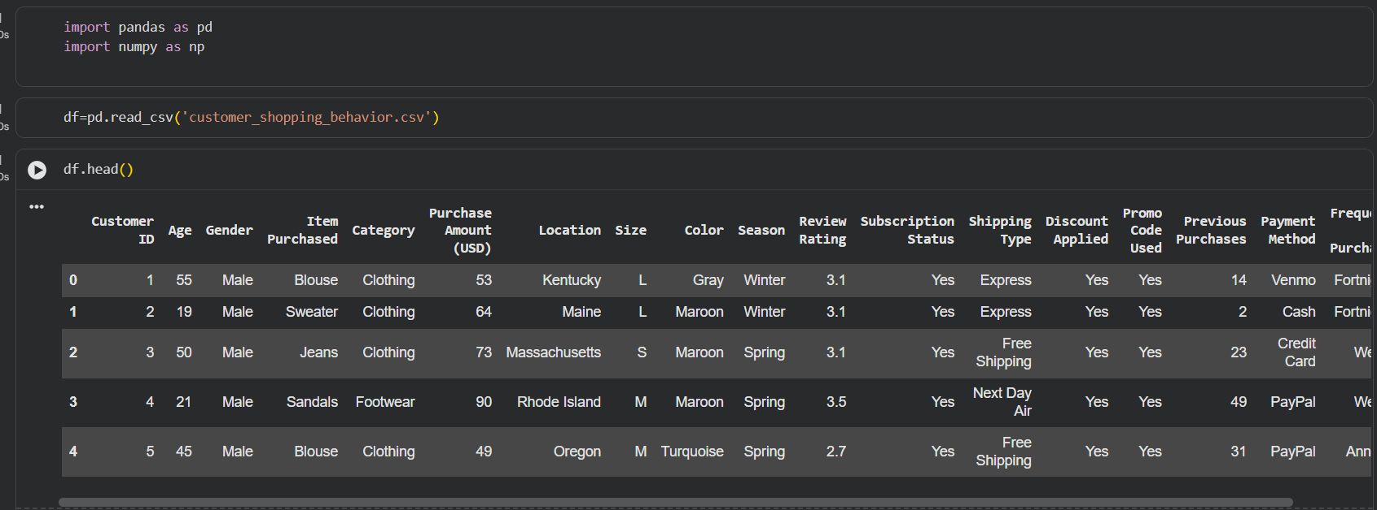
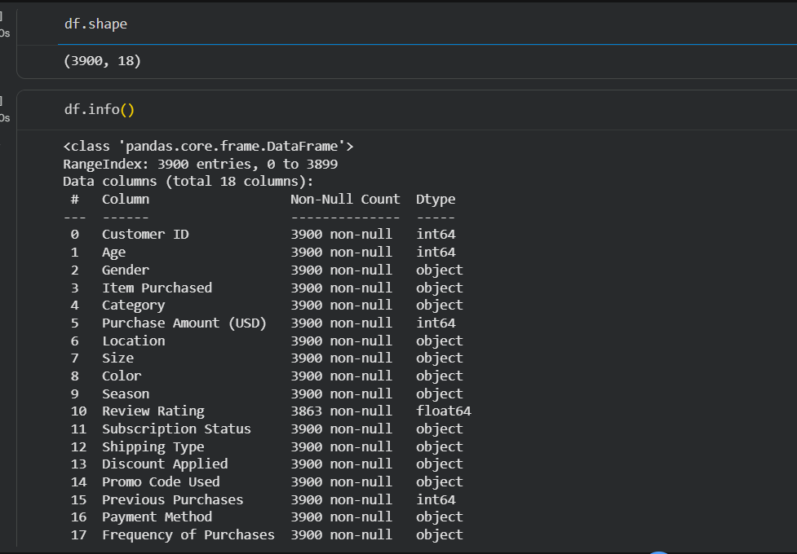

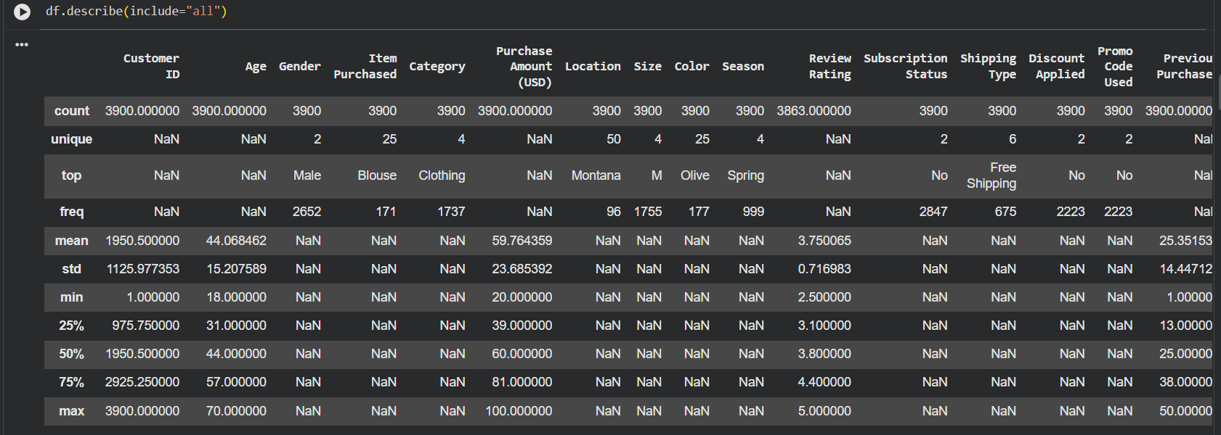

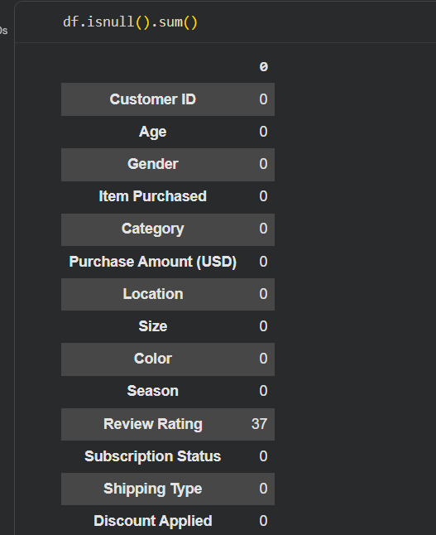
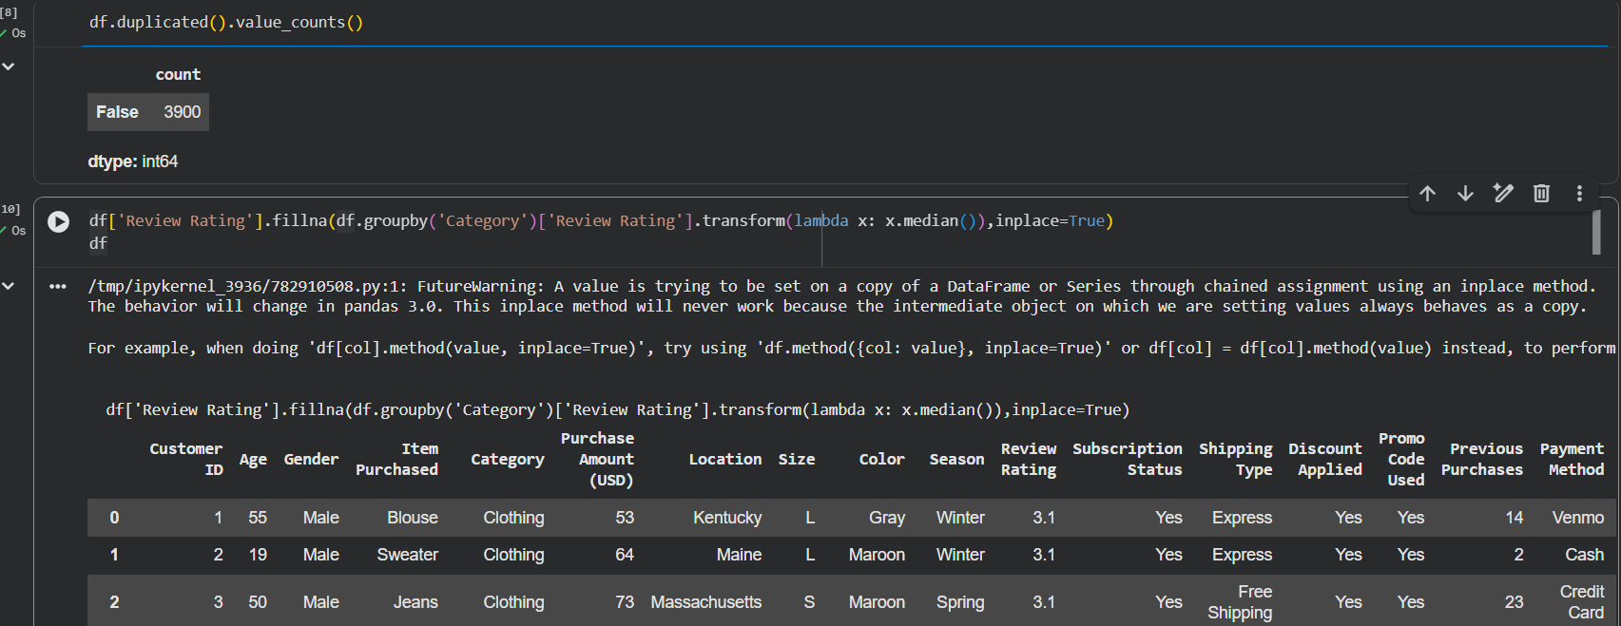

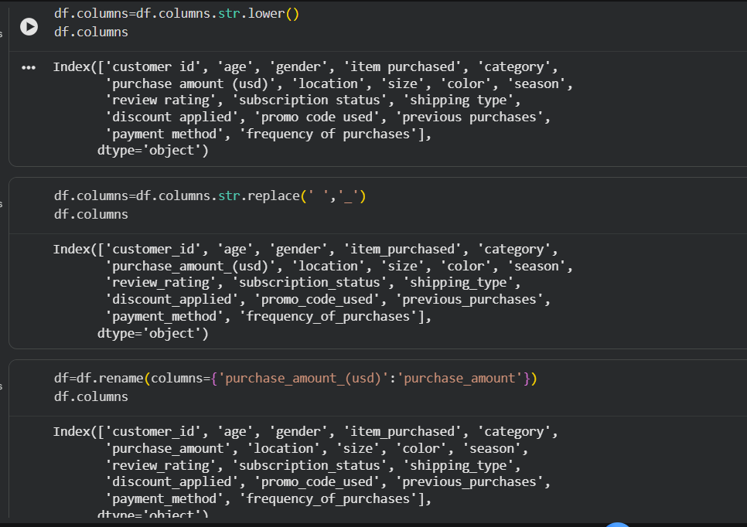
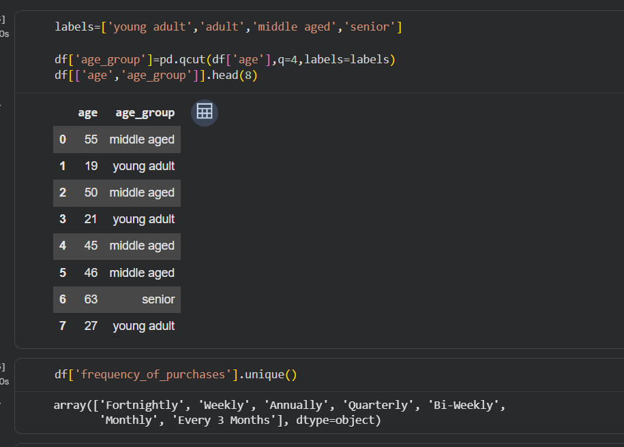

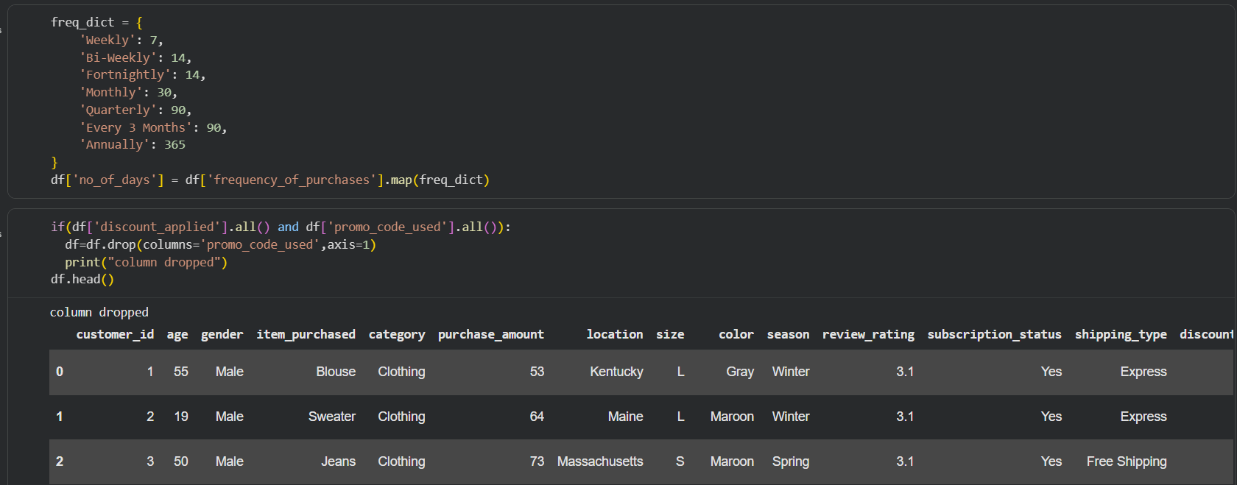

5. PostgreSQL Database Integration and Analysis
5.1 Introduction
After completing the data cleaning process in Jupyter Notebook using Pandas, the cleaned Customer Purchase Behaviour dataset was integrated with PostgreSQL. PostgreSQL was selected because it is a powerful open-source relational database management system capable of handling large datasets efficiently and supporting advanced SQL operations.
5.2 Database Connection
The cleaned dataset was connected to PostgreSQL using the PostgreSQL server and pgAdmin interface. The connection process involved:
- Creating a PostgreSQL database.
- Establishing a connection with the PostgreSQL server.
- Creating appropriate database tables.
- Importing the cleaned dataset into the database.
- Verifying successful data import.
5.3 Data Storage and Management
Once imported, the dataset was organized into structured tables. PostgreSQL provided efficient data storage, faster retrieval, better data integrity, support for complex analytical queries, and easy integration with Power BI.
5.4 SQL Query Execution
SQL queries were executed to analyze customer purchasing behavior and generate insights required for dashboard development.

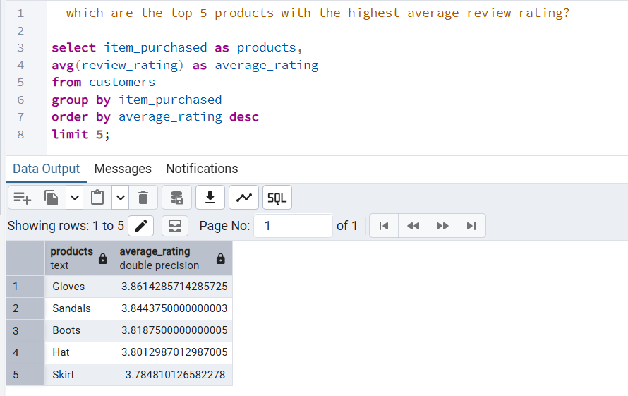

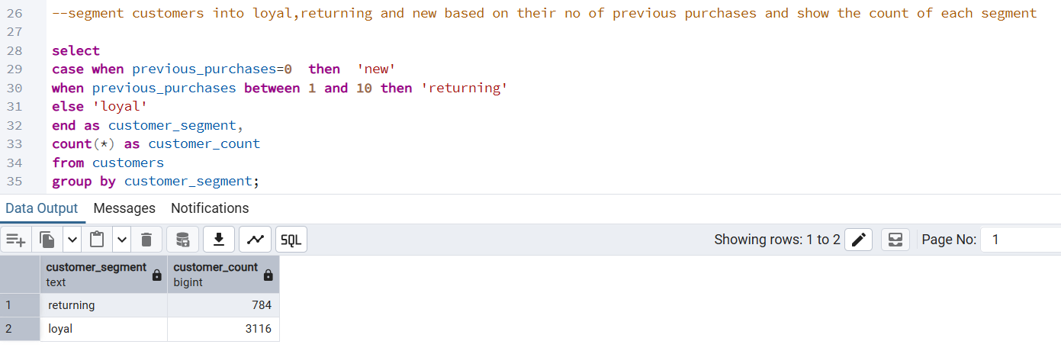

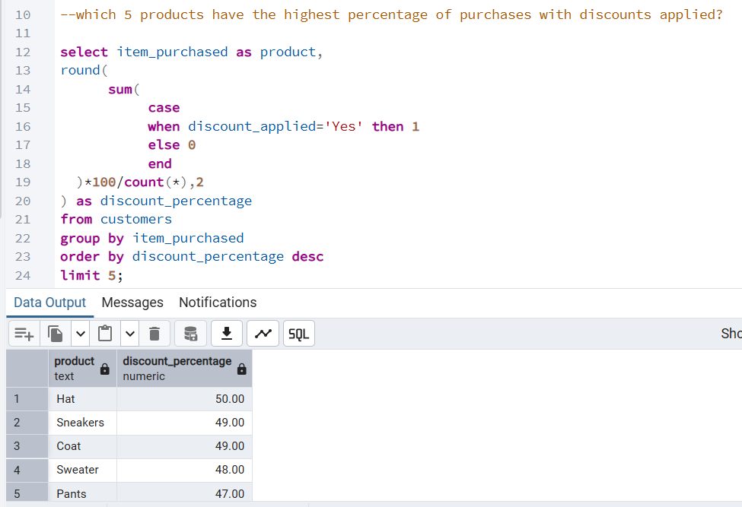

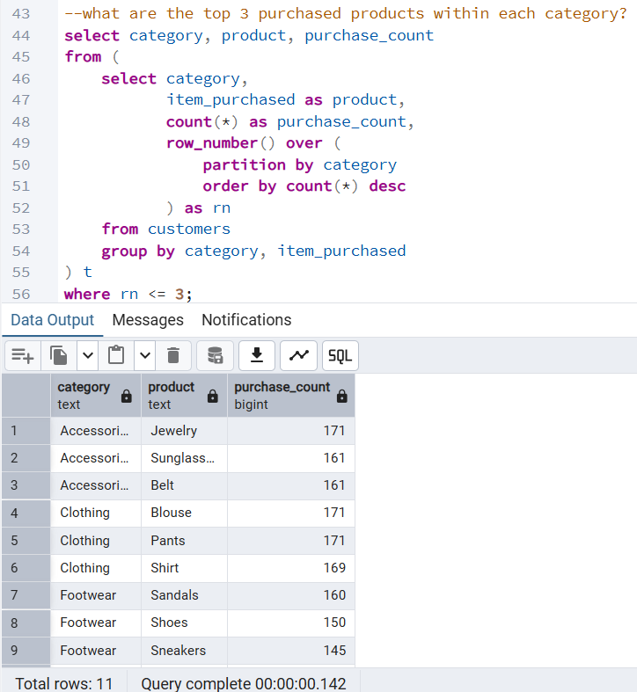

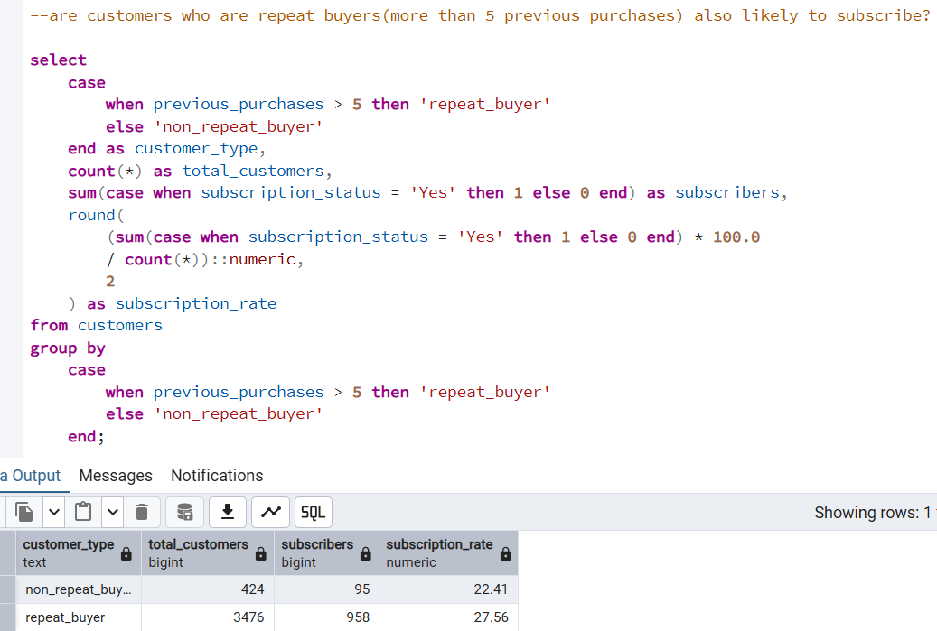

6. Data Visualization
Power BI was connected directly to PostgreSQL. The following visualizations were developed: Cards, Bar Charts, Donut Chart, Slicers, and Interactive Filters.
6.1 Dashboard Overview
The dashboard titled "Customer Behaviour Dashboard" provides a comprehensive overview of customer purchasing activities.

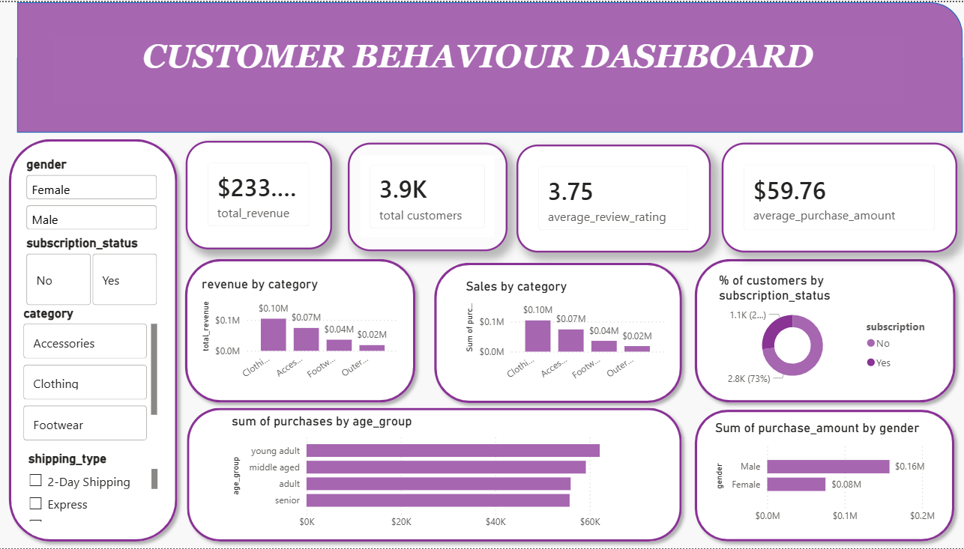

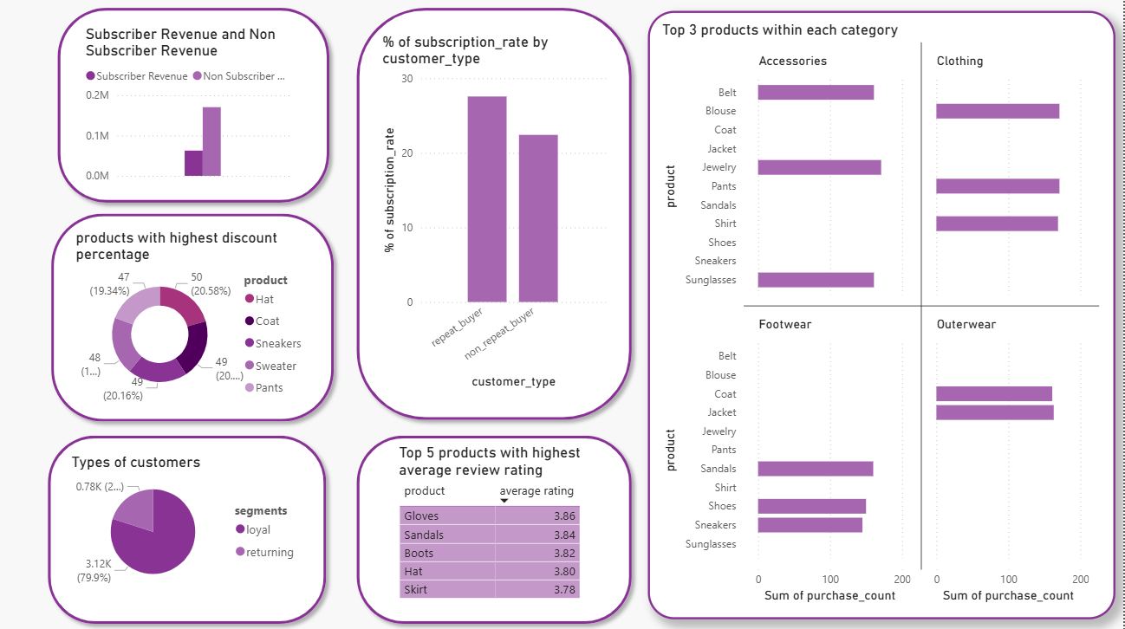

6.2 Dashboard Components

Key Performance Indicators (KPIs)

KPI | Value
Total Customers | 3.9K
Total Revenue | $233.08K
Average Purchase Amount | $59.76
Average Review Rating | 3.75

Customer Filters
The dashboard includes interactive filters for Gender, Subscription Status, Product Category, and Shipping Type.
Revenue by Category
The visualization shows total revenue generated across product categories. Clothing generates the highest revenue, Accessories contribute significantly, while Footwear and Outerwear generate comparatively lower revenue.
Subscription Status Analysis
A donut chart visualizes customer distribution based on subscription status. Majority of customers are non-subscribers while the subscriber segment represents a smaller customer base.
Purchase Amount by Age Group
Customer spending is analyzed across age groups: Young Adult, Middle Aged, Adult, and Senior. Young adults contribute the highest spending while seniors contribute comparatively lower spending.
Purchase Frequency Analysis
Purchase frequency categories include Monthly, Quarterly, Bi-Weekly, Every 3 Months, and Annually. Customers purchasing every 3 months contribute the highest spending, while monthly purchases also contribute significantly.
Revenue by Product Category

Category | Revenue Contribution
Clothing | Approximately 100,000
Accessories | Approximately 70,000
Footwear | Approximately 40,000
Outerwear | Approximately 20,000

Clothing is the most significant revenue-generating category, contributing nearly half of total revenue. Accessories represent the second-highest revenue source. Outerwear contributes the least revenue among all categories.
The organization should prioritize inventory management and promotional efforts for Clothing and Accessories. Additional marketing initiatives may be required to improve Outerwear performance.

Revenue by Gender

Gender | Revenue
Male | 157,890
Female | 75,191

Male customers generated approximately 68% of total revenue, while female customers contributed approximately 32%. Targeted campaigns aimed at increasing female customer engagement may help diversify revenue streams.
Purchase Activity by Age Group
Young adults represent the most active customer segment and contribute significantly to business activity. Senior customers demonstrate relatively lower purchase activity. Marketing campaigns should focus on young adults through digital channels and personalized promotions.
Subscription Distribution
- Subscribers: Approximately 27%
- Non-Subscribers: Approximately 73%
A large majority of customers have not subscribed to the organization's membership program, suggesting significant untapped potential for customer conversion.
Revenue by Subscription Status
Customer Type | Revenue
Non-Subscribers | 170,436
Subscribers | 62,645

Non-subscribers generate nearly three times more revenue than subscribers, indicating that the current subscription program is not driving a substantial share of business revenue.
Average Purchase Amount Comparison
Customer Type | Average Purchase Amount
Non-Subscribers | 59.87
Subscribers | 59.49

The average spending per transaction is almost identical across both groups. The difference in total revenue is driven primarily by purchase volume rather than purchase value. The organization should focus on increasing transaction frequency among subscribers.
Customer Loyalty Analysis
- Returning Customers: Approximately 3.12K (79.9%)
- Loyal Customers: Approximately 0.78K (20.1%)
The business demonstrates strong customer retention, with nearly 80% of customers making repeat purchases. There is a significant opportunity to convert returning customers into loyal customers through rewards programs and personalized offers.
Top-Rated Products

Product | Average Rating
Gloves | 3.86
Sandals | 3.84
Boots | 3.82
Hat | 3.80
Skirt | 3.78

These products consistently receive positive customer feedback and should be prioritized in promotional campaigns and recommendation systems.
Top Products by Category
Accessories
- Jewelry
- Sunglasses
- Belt
Clothing
- Pants
- Shirts
- Other clothing items
Footwear
- Sandals
- Shoes
- Sneakers
Outerwear
- Jackets
- Coats
These products represent the most frequently purchased items within their respective categories. Maintaining adequate inventory levels is essential to avoid stock shortages and lost sales.
Discount Analysis
Products receiving the highest discount percentages include Hat, Coat, Sneakers, Sweater, and Pants. Further analysis should determine whether discount strategies are translating into increased sales volume and improved profitability.

Key Findings
- Clothing category generates maximum revenue.
- Young adults are the most active purchasers.
- Average purchase amount is approximately $59.76.
- Average customer rating is 3.75.
- Non-subscribers form the majority of customers.
- Purchase frequency significantly impacts revenue generation.
- Shipping preferences influence customer purchasing behavior.

7. Conclusion and Recommendations

7.1 Conclusion
This project successfully demonstrated a complete customer analytics workflow involving data cleaning, validation, database integration, business analysis, and dashboard development. The analysis identified several important business insights:
- Total revenue exceeded 233,000 monetary units.
- Clothing emerged as the strongest-performing category.
- Male customers generated approximately 68% of revenue.
- Young adults represented the most active customer segment.
- Non-subscribers generated the majority of revenue.
- Nearly 80% of customers were returning customers.
- Gloves, Sandals, and Boots achieved the highest customer ratings.
- Outerwear generated the lowest category revenue.
The Power BI dashboard transformed these findings into an interactive business intelligence solution capable of supporting strategic decision-making.
7.2 Recommendations
- Increase investment in Clothing and Accessories, which are the highest-performing categories.
- Improve subscription program benefits to increase customer enrollment and engagement.
- Develop loyalty programs that convert returning customers into long-term loyal customers.
- Focus marketing campaigns on young adult customer segments.
- Promote highly rated products such as Gloves, Sandals, and Boots to improve customer acquisition.
- Investigate strategies to improve Outerwear category performance.
- Implement targeted campaigns aimed at increasing engagement among female customers.

By implementing these recommendations, the organization can strengthen customer relationships, improve operational performance, and support sustainable revenue growth.

